Myeloproliferative, Myelodysplastic, and Histiocytic Disorders
Kenneth L. McClain, MD PhD

1. A 5-year-old girl with hepatosplenomegaly and an abnormal peripheral blood smear is referred to your clinic for evaluation. Her hemoglobin is 7.3 g/dL, WBC 1,500 with 15% blasts, and platelet count 20,000/mcL. Cytogenetic analysis shows absence of one chromosome 7.

What is the most likely diagnosis for this patient?

A. Acute myeloid leukemia
B. Acute lymphoblastic leukemia
C. Myelodysplastic syndrome
D. Chronic myeloid leukemia

Explanation
Patients with pancytopenia and less than 20% blasts in the marrow with a –7 cytogenetic finding have classic myelodysplastic syndrome.

2. Which of the following statements characterize the outcome of treating patients with myelodysplastic syndrome (MDS) versus acute myeloid leukemia (AML) with AML-type therapy?

A. Remission induction is superior in patients with MDS.
B. Failure of inductions is no different between MDS and AML.
C. Frequency of deaths is lower in patients with MDS.
D. Five-year survival is worse in patients with MDS.

Explanation
The CCG2891 provided one of the only comparison studies for treatment of AML and MDS by identical therapy. The remission induction rate was 57% for MDS versus 78% for AML; failures, 32% in MDS and 15% in AML; deaths, 11% in MDS and 6% in AML; 5-year overall survival 33% in MDS and 47% in AML.

3. Transient abnormal myelopoiesis (TAM) in infants with Down syndrome may resolve spontaneously, but approximately 25% of patients will die. What is the leading cause of death for these patients?

A. Liver failure
B. Thrombosis
C. Megakaryocytic leukemia
D. Cardiac failure

Explanation
In Homans’s review of TAM, 10 of 35 (11%) of patients died in the first few months with non-malignancy-associated conditions: heart failure, hyperviscosity, sepsis, and “crib death.” Twenty-eight patients later developed leukemia, of whom 14 (50%) died. Most of these patients have acute megakaryocytic leukemia.

4. A 2-week-old infant with Down syndrome and hepatosplenomegaly is found to have circulating blasts, and leukemia is suspected. The bone marrow aspirate is not consistent with acute lymphoid leukemia.

What French-American-British classification type is most likely?

A. M6 erythroleukemia
B. M1 acute myeloid leukemia with differentiation
C. M7 acute megakaryocytic leukemia
D. M5 monocytic leukemia
E. M4 myelomonocytic leukemia

Explanation
Children with Down syndrome have a 10- to 100-fold elevated incidence of acute leukemia. The ratio of acute lymphoblastic leukemia to acute myeloid leukemia in children with Down syndrome is 4:1. Megakaryocytic leukemia is the most common type of myeloid leukemia, with 400-fold excess risk.

5. The inpatient consult team is asked to see a 14-month-old girl who has been admitted to another service with pallor, fever, skin rash, lymphadenopathy, and hepatosplenomegaly. She has many myeloid precursors in the peripheral smear, a WBC of 100,000/mcL, monocytosis of 1 × 10⁹/L, and elevated fetal hemoglobin for age. The bone marrow aspirate shows 15% blasts. A sample is sent for evaluation of response to GM-CSF show a hypersensitivity of monocytes in vitro.

What is the most likely diagnosis?

A. Chronic myeloid leukemia
B. Acute myeloid leukemia (AML) M0
C. AML M5
D. AML M4
E. Juvenile myelomonocytic leukemia (JMML)

Explanation
This is a classic story for JMML, with peripheral blood monocytosis in a greatly elevated WBC (often more than 100,000) and in vitro hypersensitivity of monocytes to proliferation with GM-CSF. The patients rarely have more than 20% blasts in the bone marrow and most often have normal cytogenetic analysis of the marrow.

6. The molecular pathogenesis of juvenile myelomonocytic leukemia (JMML) is closely linked with activating mutations of which family of genes?

A. AML/RUNX1
B. BCR/Abl
C. GATA1
D. RAS
E. Myc/IgG light chain

Explanation
Shannon and colleagues have written several landmark articles showing that activation of RAS genes (PTPN1, NRAS, and KRAS) occurs in 60% of patients with JMML. Ten percent to 15% of patients with JMML also have deletions of NF1, which is a negative regulator of RAS signaling.

7. PTPN11 mutations have been identified in approximately 40% of patients with Noonan syndrome (NS). Those with the mutation almost always have cardiovascular anomalies and hematologic abnormalities. The patients develop juvenile myelomonocytic leukemia (JMML).

Which of the following most frequently occurs with JMML in these patients?

A. It goes into spontaneous remission.
B. It becomes true acute myeloid leukemia.
C. It is characterized by thrombocytopenia lasting years.
D. It is characterized by chronic neutropenia.

Explanation
Children with NS are at increased risk of developing JMML or a myeloproliferative disorder associated with NS (MPD/NS) resembling JMML in the first weeks of life. While JMML is an aggressive disorder necessitating hematopoietic stem cell transplant, MPD/NS may resolve without treatment, and cases with spontaneous remission also have been reported.

8. A 5-year-old boy presented with pallor, fatigue, and low-grade fevers. His physical exam showed minimal splenomegaly, petechiae, and no adenopathy. Laboratory data include a hemoglobin of 6 and MCV of 102; WBC of 2,000; and platelets of 40,000. His bone marrow aspirate shows bizarre megaloblastic erythroid cells with abnormal maturation of the nuclei, dysplastic megakaryocytes, and nuclear bridging of the neutrophils with 5% blasts.

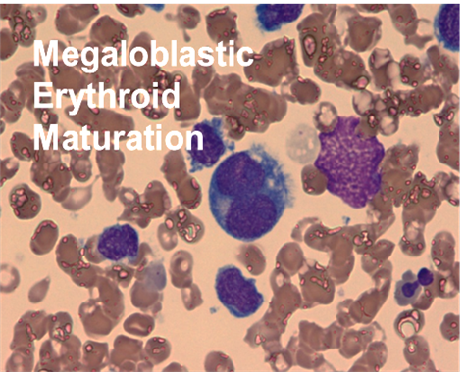

What is the most likely diagnosis?

A. Aplastic anemia
B. Vitamin B₁₂ deficiency
C. Myelodysplastic syndrome (MDS)
D. Acute megakaryocytic leukemia
E. Erythroleukemia

Explanation
MDS causes all the bone marrow findings listed for this patient. Although some patients with MDS have blasts, they usually are much less than 20%. Erythroleukemia may cause similar features in erythroid precursors but will have more than 20% blasts, as would megakaryocytic leukemia. Vitamin B₁₂ deficiency could cause all the peripheral blood abnormalities and the marrow findings, perhaps with the exception of neutrophil nuclear bridging and 5% blasts.

9. Langerhans cell histiocytosis (LCH) affects the skin and bones of most patients, and a smaller number have involvement of the liver, spleen, and bone marrow. The overall survival of patients depends on the sites of disease. Which of the following patients with LCH in the noted sites is considered “high risk” for not surviving?

A. Mastoid, orbit, femur, skin
B. Pituitary, mastoid, lung
C. Skin, liver
D. Colon, skin, humerus, ribs, vertebrae
E. Pituitary, radiologic evidence of neurodegenerative syndrome

Explanation
The “high-risk” organs are liver, spleen, and bone marrow. In the LCH-III study, mortality was 12%, but more than 40% needed additional treatments beyond Velban and prednisone. Lung is no longer considered a high-risk organ. Patients with bone, skin, pituitary, and lymph node LCH are all cured. Those with only radiologic evidence of the neurodegenerative syndrome do not die of this.

10. Elevated ferritin levels are associated with chronic transfusions and a variety of inflammatory conditions, including hemophagocytic lymphohistiocytosis (HLH). What level of ferritin is considered 90% sensitive and 96% specific for HLH?

A. 300
B. 500
C. 1,000
D. 10,000
E. 50,000

Explanation
Although patients with shock may have ferritin values up to 9,000, none of the patients with infections reviewed in Allen and colleagues’ 2008 article, “Highly Elevated Ferritin Is Specific and Sensitive for HLH,” had ferritin levels close to 10,000. The exceptions are obvious clinically in that patients with post–stem cell transplant mucositis have ferritin levels up to 46,700, and chronically transfused patients with poor chelation therapy may be in the 10,000 to 20,000 range.

11. A child presents with a 6-month history of progressive proptosis of his left eye. When you examine him you discover subcutaneous nodules on his back and abdomen. A skeletal survey shows some linear lytic lesions in his left humerus and in both femurs.

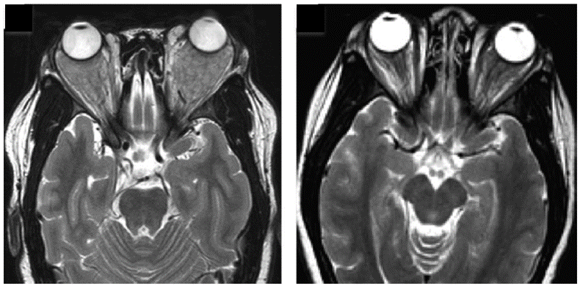

What is the most likely diagnosis?

A. Langerhans cell histiocytosis (LCH)
B. Rhabdomyosarcoma
C. Juvenile xanthogranuloma
D. Rosai-Dorfman disease

Explanation
Elements of this child’s presentation cross over all the diagnoses listed. Although patients with LCH often have proptosis, they do not have subcutaneous nodules, and their bone lesions are well circumscribed and circular. Rhabdomyosarcoma is also a reasonable diagnostic consideration, but it rarely causes nodules or bone lesions. Juvenile xanthogranuloma rarely is found behind the eyes; it is more common in the sinuses or brain and makes visible cutaneous papules and no bone lesions.

12. Patients with Langerhans cell histiocytosis who have lesions of the orbit, temporal bone, or mastoid have a higher incidence of diabetes insipidus than those having skull lesions in other locations. What long-term nonendocrine problem are these patients at risk for?

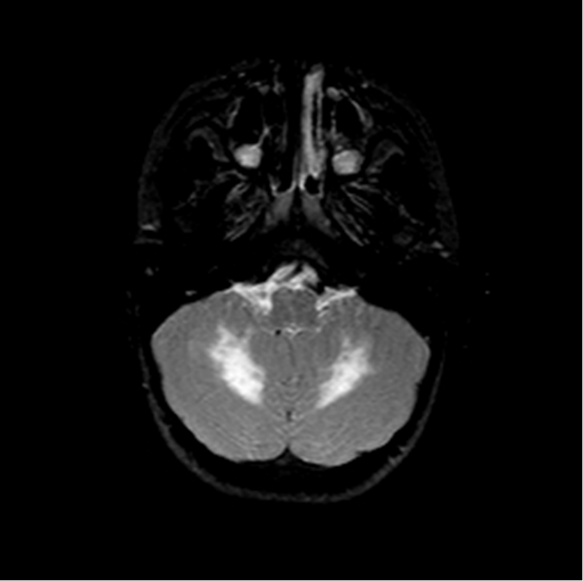

A. Chronic infections of those sites
B. Brain tumors
C. Neurodegenerative syndrome
D. Scalp rashes

Explanation
The relative risk of neurodegenerative syndrome is controversial but is probably in the 2% to 5% range. It is hypothesized that the cells from these lesions enter vascular pathways to the pituitary and hypothalamus (often causing diabetes insipidus) and then make their way to the cerebellum, pons, and basal ganglia. The few histologic investigations done in these patients show CD8+ lymphocytes, microglial proliferation, and nerve death, leading to the symptoms of ataxia, dysmetria, dysarthria, and learning difficulties. Brain MRIs show T2 intense signal in the FLAIR images in the brain regions listed above.

13. The diagnostic criteria for hemophagocytic lymphohistiocytosis include fever, hepatomegaly or splenomegaly, decrease in two cell lines, elevated triglycerides, elevated ferritin, elevated interleukin 2 receptor, and decreased natural killer cell function.

Which criterion cited is most variable or least helpful?

A. Increased ferritin
B. Increased triglycerides
C. Hemophagocytosis
D. Decrease in two cell lines

Explanation
A review of several studies of patients with hemophagocytic lymphohistiocytosis reporting on the percentage of patients with hemophagocytosis in the marrow showed a range of 20% to 100%, with most being around 50%. This variability is likely due to the varying tempo of the disease or perhaps the different etiologies (infectious versus genetic).

14. A 2-month-old infant is brought to your clinic with an extensive scaly rash on the scalp, which has been biopsied and shown to be Langerhans cell histiocytosis (LCH). You want to determine whether this patient has skin-only LCH or involvement of any of the “high-risk” organs. The child has a normal CBC; normal liver enzymes and bilirubin; and a normal skeletal survey, skull films, and chest X ray.

What other screening test will be important for finding involvement of a high-risk organ?

A. Reticulocyte count
B. Erythrocyte sedimentation rate
C. Alkaline phosphatase
D. Serum albumin and total protein

Explanation
Serum albumin and total protein are very sensitive for detecting decreased synthetic capacity of the liver and are often abnormal before liver enzymes and bilirubin are elevated. Of course, the albumin and protein could be low if the child has chronic diarrhea from intestinal involvement. If that symptom is present, one should do endoscopy with biopsies to prove intestinal involvement. Liver involvement can be proven by biopsy, which may show CD1a+ cells infiltrating the liver or just lymphocytic infiltrates. A CT or ultrasound of the abdomen will demonstrate a hypodense signal along the biliary tracts.

15. You are reviewing with your pathologist the lymph node biopsy of a child suspected of having a histiocytic disease. The H&E stain shows large cells with pink cytoplasm and normal lymphocytes in the cytoplasm. The cells are CD1a negative, fascin negative, CD68 positive.

H&E CD68+ S100A+
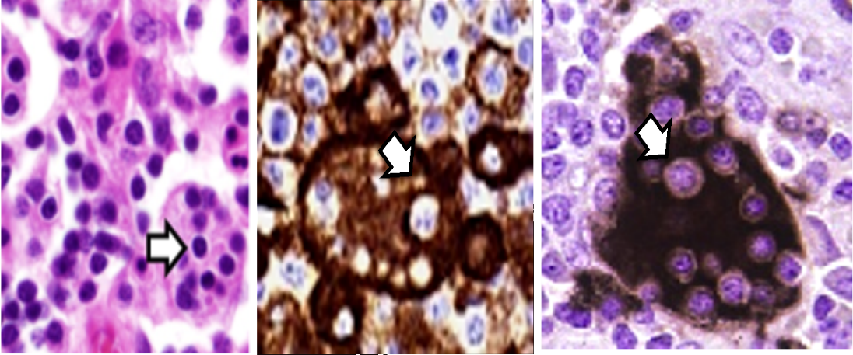

What is the diagnosis?

A. Rosai-Dorfman disease
B. Juvenile xanthogranuloma
C. Hemophagocytic lymphohistiocytosis
D. Langerhans cell histiocytosis
E. Reactive lymphadenopathy

Explanation
The phenomenon of normal-appearing lymphocyte harbored in the cytoplasm of CD68 macrophages is diagnostic of Rosai-Dorfman disease and is known as emperipolesis.

